📄 Insight Stream – News Website Documentation

1. Introduction

Project Title: Insight Stream –navigate the new landscape

Team leader:

KIRUTHIKA R(202400601)

Team members:

[Member 1] – J.Jayavarshini(202400508)

[Member 2] – v.Kavika(202400574)

[Member 3] _ J.Jerina priyadharshini(202400)

---

2. Project Overview

Purpose:

The goal of Insight Stream is to provide users with real-time, categorized, and reliable news articles in a clean and interactive interface.

Features:

Live news updates fetched via API.

Category-wise filtering (Politics, Technology, Sports, Entertainment, etc.).

Search functionality for specific news topics.

Responsive design for mobile and desktop users.

Bookmarking favorite articles.

---

3. Architecture

Component Structure:

App.js → Root component.

Navbar.js → Navigation bar with categories.

NewsList.js → Displays news articles.

NewsCard.js → Individual news article card.

SearchBar.js → For searching news topics.

Bookmark.js → Saved articles section.

State Management:

Implemented using Context API for global state.

Handles news data, bookmarks, and category filtering.

Routing:

Implemented with React Router DOM.

Routes: /, /category/:name, /search, /bookmarks.

---

4. Setup Instructions

Prerequisites:

Node.js (v16+ recommended)

npm or yarn

Installation:

git clone https://github.com/username/insight-stream.git

cd insight-stream

npm install

npm start

---

5. Folder Structure

/insight-stream

┣ /public

┣ /src

┃ ┣ /components

┃ ┃ ┣ Navbar.js

┃ ┃ ┣ NewsCard.js

┃ ┃ ┣ SearchBar.js

┃ ┃ ┣ Bookmark.js

┃ ┣ /pages

┃ ┃┣ Home . js

┃ ┃ ┣ Category.js

┃ ┃ ┣ SearchResults.js

┃ ┃ ┣ Bookmarks.js

┃ ┣ /context

┃ ┃ ┗ NewsContext.js

┃ ┣ App.js

┃ ┣ index.js

┣ package.json

---

6. Running the Application

Frontend:

npm start

Runs the app in development mode at http://localhost:3000/.

---

7. Component Documentation

Key Components:

Navbar → Navigation across categories.

NewsList → Renders fetched articles.

NewsCard → Displays article title, description, image, and source.

Reusable Components:

Button, Loader, Modal.

---

8. State Management

Global State:

News API data, selected category, search results.

Local State:

Pagination handling, modal visibility, input fields.

---

9. User Interface

Responsive Material UI + Tailwind CSS design.

Mobile-friendly layout.

Screenshots/GIFs showing:

Home Page with latest news.

Category selection.

Bookmarked articles view.

---

10. Styling

CSS Frameworks/Libraries:

Tailwind CSS

Material UI Components

Theming:

Light/Dark mode toggle.

---

11. Testing

Testing Strategy:

Unit tests for components with Jest.

UI testing with React Testing Library.

Code Coverage:

Ensuring >80% coverage.

---

12. Screenshots :

Screenshots of homepage, categories, and bookmarks:

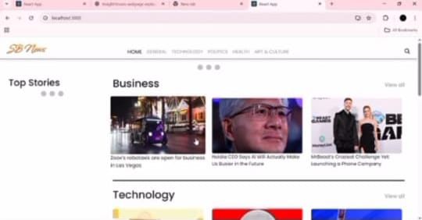

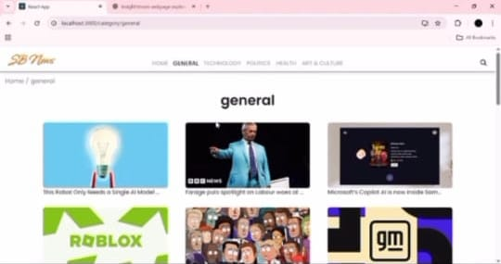

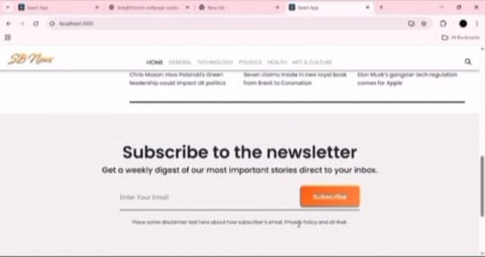

Demo link (if hosted):

<https://drive.google.com/file/d/1zpiaSuVtIJIIs2Fkv21qBHGpzC6jebbT/view?usp=drivesdk>

---

13. Known Issues

Sometimes API rate limits may cause delays.

Search performance can be optimized for large datasets.

---

14. Future Enhancements

Add AI-powered news summarization.

Implement push notifications for breaking news.

Support for multiple languages.

Progressive Web App (PWA) support.

---

✨ That’s your complete React.js documentation for a News Website.